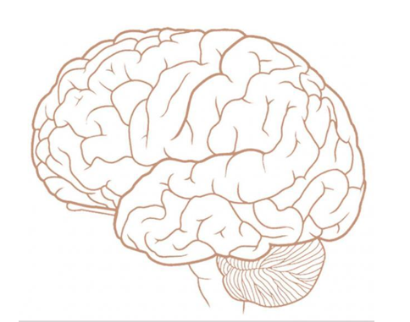
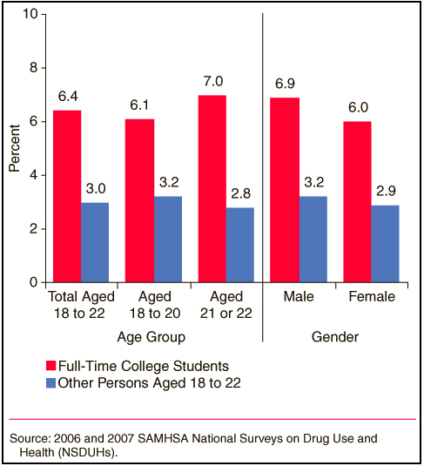
Addiction, Adderall, and the Brain

By Stephanie Biecker
Why is Adderall
(Amphetamine Dextroamphetamine)
so addictive?

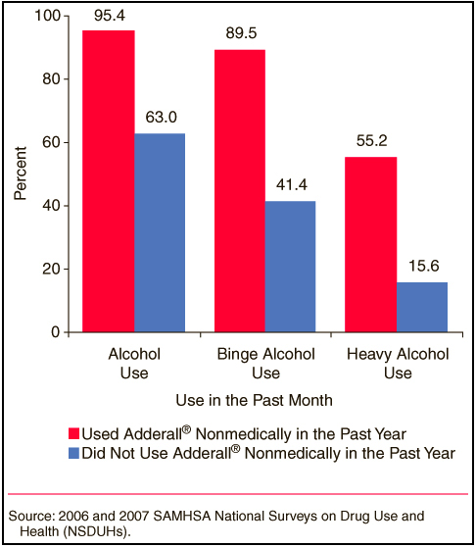
Who is at risk?
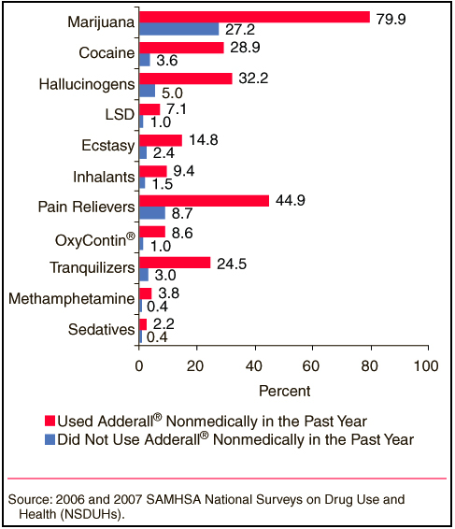
Drug Side Effects
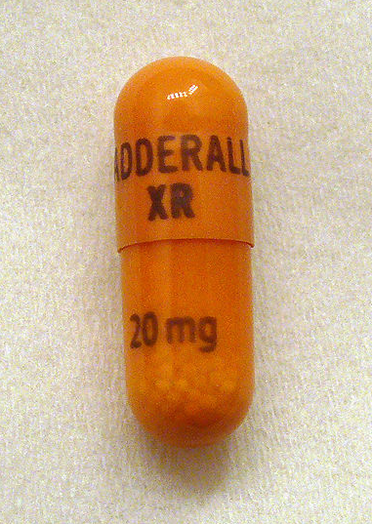
- Disrupted heart rhythm and increased blood pressure
- Loss of appetite
- Headaches
- Dryness of mouth
- Issues sleeping
- Increase chances of alcohol poisoning
Long Term Abuse Health Issues
- Cardiovascular problems
- Depression
- Hostility/Stress
- Paranoia/Delusions
- Inhibits growth in children
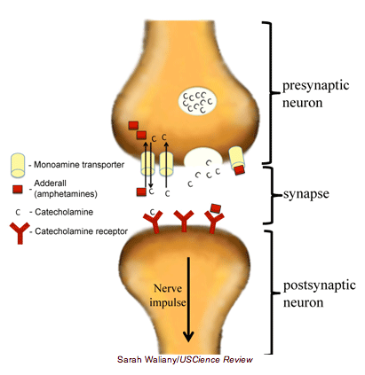
How Adderall Works
Issues regarding Prescribed and Abused Adderall Use
- Causes hallucinations
- Long term use permanently alters brain (synaptic plasticity)
- Continued loss of DA
- Adderall tricks brain to stop DA synthesis
- Loss of catecholamine
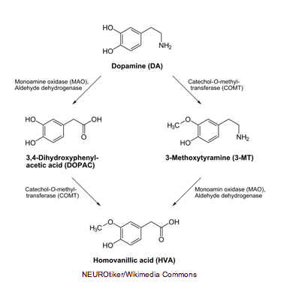
Metabolism of dopamine by monoamine oxidase
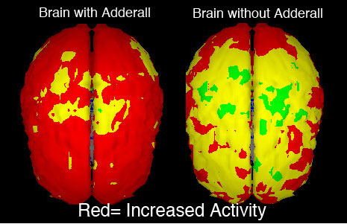
How Adderall activates the Brain

Why it is abused
- Causes a sense of euphoria
- Releases 5-HT, DA, & Adrenaline
- Psychologically & Physical addiction
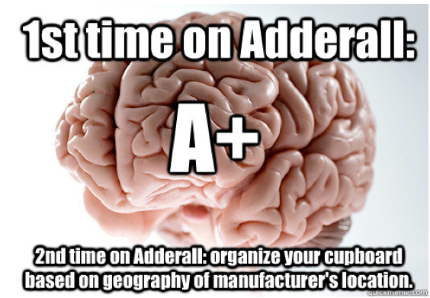
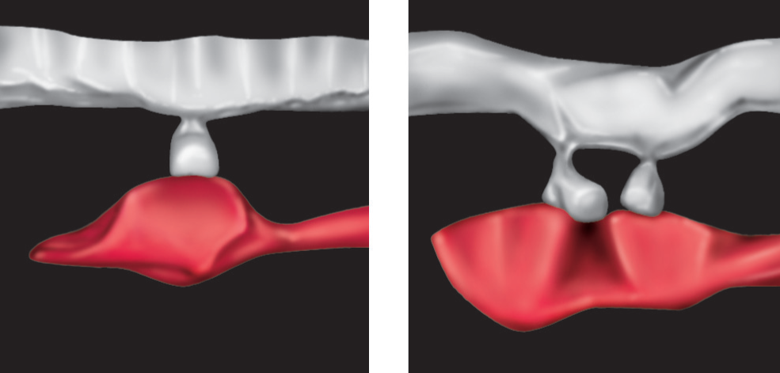
Synaptic Plasticity Example (because it is awesome)

Why do students continue to abuse Adderall given the scientific evidence?
What are the most abused drugs here at the University of Kentucky?

A not so interesting, interesting fact….
So what does this small molecule do?
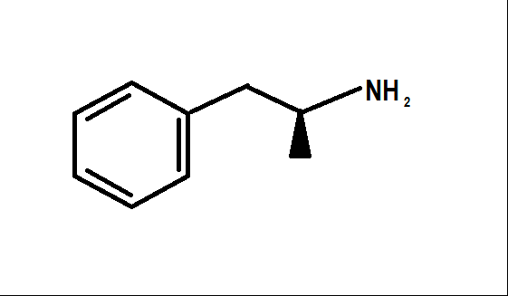

ADDERALL
(Not that we should be celebrating)

